*Florida International University*

*School of Computing and Information Sciences*

CIS 4911 - Senior Capstone Project

Software Engineering Focus

Feature Document

User Story #975

**Team Member:**

**Michael Martinez**

**Product Owner(s)**:

Masoud Sadjadi

**Mentor(s)**:

Mohsen Taheri

**Instructor**:

Masoud Sadjadi

**User Story**

Review Student Applications

**Description**

* As a VIP Co-PI/PI/Faculty user, I would like to review student applications so that I can approve any students that want to work on a project.

**Acceptance Criteria**

1. The “Prospective Students -> Review Student Applications” page needs to be created.
2. Allows for student applications to be reviewed by Co-Pi/PI/Faculty

**Use Case**

Details:

Actor: User(Co-Pi/PI or Faculty)

Pre-conditions:

1. User is a Co-PI/PI or Faculty.
2. User has navigated to the “Review Student Applications”.

Description:

1. Use case begins when user goes to Review Student applications.
2. User can look at the students who applied to their selected projects and then can choose to accept them.
3. Use case ends, when user accepts and it will send an email to the student notifying them that their application has been approved.

Post-conditions:

1. N/A

Alternative Courses of Action:

1. Use case begins when user goes to Review Student applications.
2. User can look at the students who applied to their selected projects and then can choose to reject them.
3. Use case ends, when user rejects and it will send an email to the student notifying them that their application got rejected.

Decision Support:

Frequency: Medium. Co-Pi/Pi or Faculty will use this in the beginning of every semester.

Criticality: High. Important so users can be accepted or rejected for projects.

Risk: Medium-Low.

Constraints:

1. Usability:
   1. No training time required.
2. Reliability:
   1. Mean time to failure - No failure is acceptable.
   2. Availability- Always available.
3. Performance:
   1. Response Time - should load as soon as user clicks on it.
   2. Throughput - the system should accomplish work within 50 ms.
   3. Availability - always available unless maintenance.
4. Supportability:
   1. Feature must appear on mobile devices and nonmobile devices.

Modification History:

Owner: Michael Martinez

Initiation date: 06/7/2016

Date Last modified: 06/7/2016

**Use Case Diagram**

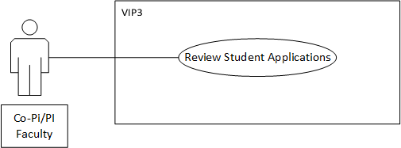

**Sequence Diagram**

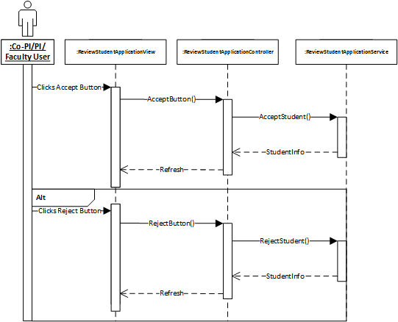

**Class Diagram**

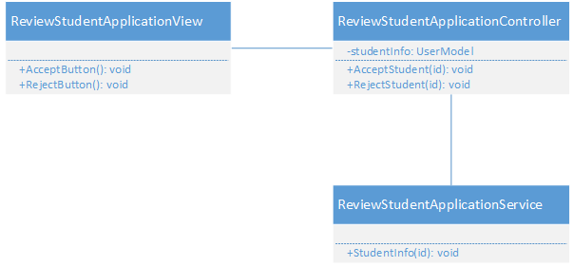

**Unit Test & Integration Test**

* **Test Case 1**
  + **Purpose:** Test that Accept will change the add the Student to the project and notify them by email.
  + **Precondition:** User must be a Co-PI/PI
  + **Expected Result:** Student is added to project and notified.
  + **Actual Result:** Same as expected.
  + **Status: PASS**
* **Test Case 2**
  + **Purpose:** Test that Reject will delete the student application request and notify them by email.
  + **Precondition:** User must be a Co-PI/PI
  + **Expected Result:** Student application deleted and notified.
  + **Actual Result:** Same as expected.
  + **Status: PASS**

**Visual User Guide**

**1)Go to Review Student application page**

**2) Choose to approve or reject a student.**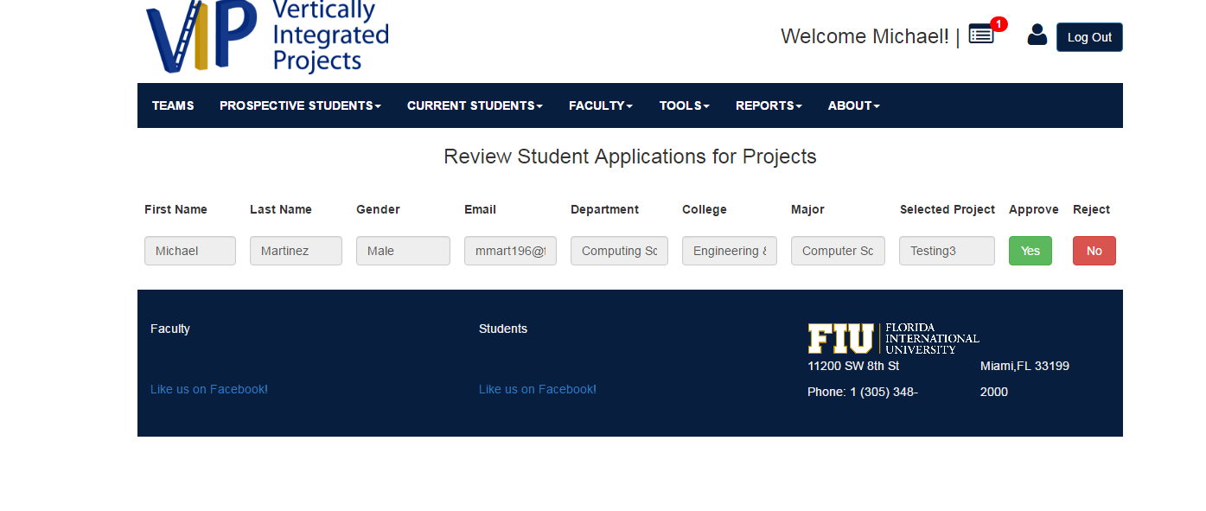

**3)After, the application will disappear and the student will be notified.**

